**1. Implementing Sorting using GridView**

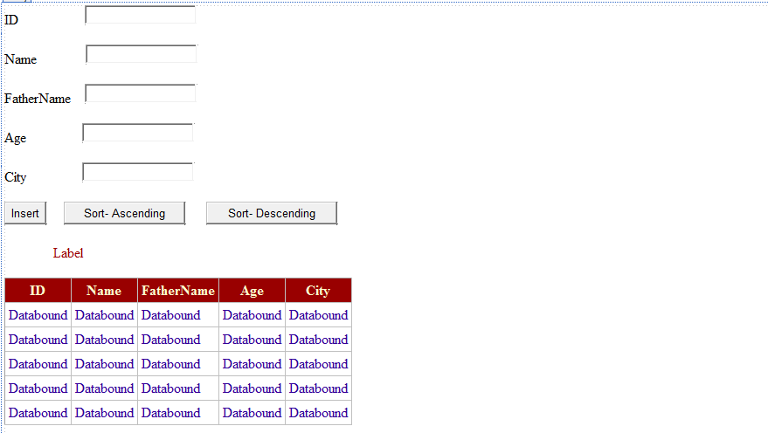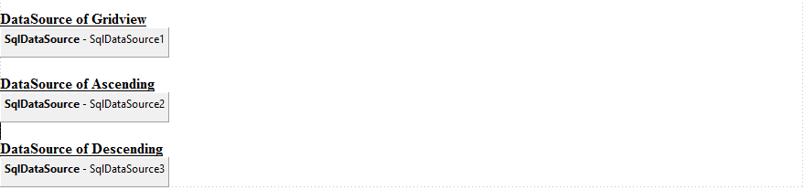

using System.Data;

using System.Data.SqlClient;

public partial class form : System.Web.UI.Page

{

protected void Page_Load(object sender, EventArgs e)

{

}

protected void Button1_Click(object sender, EventArgs e)

{

SqlConnection con = new SqlConnection("");

con.Open();

string Insert = "Insert into Table1 values ('" + TextBox1.Text + "','" + TextBox2.Text + "','" + TextBox3.Text + "','" + TextBox4.Text + "','" + TextBox5.Text + "')";

SqlCommand cmd = new SqlCommand(Insert, con);

cmd.ExecuteNonQuery();

con.Close();

//Show Message

Label6.Visible = true;

Label6.Text = "Record Inserted Successfully";

// Clear all fields

TextBox1.Text = ("");

TextBox2.Text = ("");

TextBox3.Text = ("");

TextBox4.Text = ("");

TextBox5.Text = ("");

}

protected void Button2_Click(object sender, EventArgs e)

{

Label6.Text = "ID Displayed in Ascending Order";

GridView1.DataSourceID = "";

GridView1.DataSource = SqlDataSource2;

GridView1.DataBind();

GridView1.Visible = true;

}

protected void Button3_Click(object sender, EventArgs e)

{

Label6.Text = "ID Displayed in Descending Order";

GridView1.DataSourceID = "";

GridView1.DataSource = SqlDataSource3;

GridView1.DataBind();

GridView1.Visible = true;

}

}

**2. Implementing Paging using GridView**

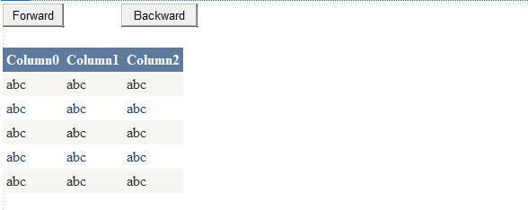

using System.Data;

using System.Data.SqlClient;

public partial class Paging : System.Web.UI.Page

{

int start= 0;

SqlDataAdapter da = new SqlDataAdapter();

DataSet ds = new DataSet();

protected void Page_Load(object sender, EventArgs e)

{

SqlConnection con = new SqlConnection("");

SqlCommand cmd = new SqlCommand ("Select * from Table1", con);

da.SelectCommand = cmd;

da.Fill(ds, start, 5, "Table1");

GridView1.DataSource = ds;

GridView1.DataBind();

//Disable Backward Button

Button2.Enabled= false;

}

protected void Button1_Click(object sender, EventArgs e)

{

start = start + 5;

Button2.Enabled = true;

if (start > 10)

{

start = 0;

}

ds.Clear();

da.Fill(ds, start, 5, "Table1");

}

protected void Button2_Click(object sender, EventArgs e)

{

start = start - 5;

if (start < 0)

{

start = 0;

Button2.Enabled = false;

}

ds.Clear();

da.Fill(ds, start, 5, "Table1");

}

}

**3. Implementing Filtering using GridView**

Model binding adds several attributes which enable you to designate how to set the value for a parameter in a model binding method. These attributes are in the **System.Web.ModelBinding** namespace. They include:

* **Control**
* Cookie
* Form
* Profile
* QueryString
* RouteData
* Session
* UserProfile
* ViewState

In this tutorial, you will use a control's value to filter which records are displayed in the GridView. You will add the **Control** attribute to the query method you had created earlier. Add a drop down list for filtering which Cities are shown.

<asp:DropDownList runat="server" AutoPostBack="true" ID="DisplayYear">

<asp:ListItem Text="All" Value="" />

<asp:ListItem Text="Freshman" />

<asp:ListItem Text="Sophomore" />

<asp:ListItem Text="Junior" />

<asp:ListItem Text="Senior" />

</asp:DropDownList>

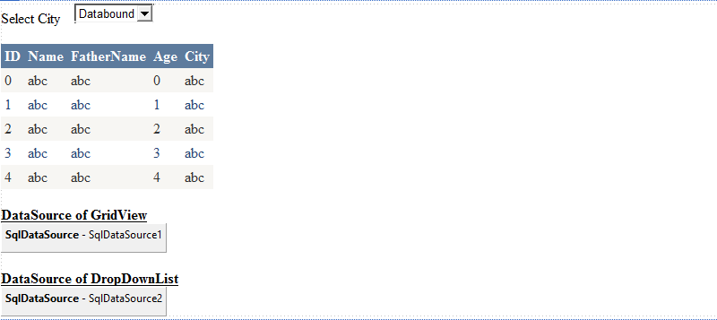

**4. Storing DataSet in ViewState**

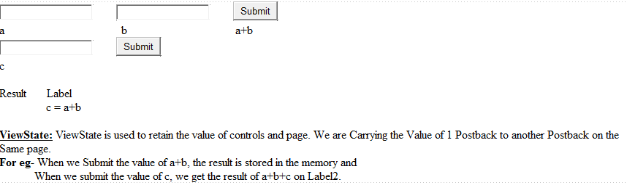

using System.Web.UI;

using System.Web.UI.WebControls;

public partial class ViewState : System.Web.UI.Page

{

protected void Page_Load(object sender, EventArgs e)

{

if (IsPostBack == false)

//Declaring a Variable

ViewState.Add("Val", 0);

}

protected void Button1_Click(object sender, EventArgs e)

{

int x = int.Parse(TextBox1.Text.ToString());

int y = int.Parse(TextBox2.Text.ToString());

int z = x + y;

//Assigning a value to the Variable

ViewState["Val"] = z.ToString();

}

protected void Button2_Click(object sender, EventArgs e)

{

int a = int.Parse(TextBox3.Text.ToString());

//Reading the Variable

int b= int.Parse(ViewState["Val"].ToString());

int c = a + b;

Label2.Text = c.ToString();

}

}

**5. Updating a Database**

using System.Data;

using System.Data.SqlClient;

public partial class UpdateDatabase : System.Web.UI.Page

{

protected void Page_Load(object sender, EventArgs e)

{

}

protected void Button1_Click(object sender, EventArgs e)

{

SqlConnection con = new SqlConnection("Data Source=.\\SQLEXPRESS;AttachDbFilename=" + Server.MapPath("App_Data\\Database.mdf") + ";Integrated Security=True;User Instance=True");

con.Open();

string Update = "Update Table1 SET Name='" + TextBox2.Text + "', FatherName='" + TextBox3.Text + "', Age='" + TextBox4.Text + "', City='" + TextBox5.Text + "' WHERE ID= '" + TextBox1.Text + "'";

SqlCommand cmd = new SqlCommand(Update, con);

cmd.ExecuteNonQuery();

con.Close();

//Show Message

Label6.Visible = true;

Label6.Text = "Record Updated Successfully";

// Clear all fields

TextBox1.Text = ("");

TextBox2.Text = ("");

TextBox3.Text = ("");

TextBox4.Text = ("");

}

}

